Document-04: RedshiftQueries.pdf
Project: ATM Transactions Data Analysis
Document: Redshift Analytical Queries
Student Name:
Platform: Amazon Redshift / AWS S3 via PySpark
Date: November 2025

1. Dataset Overview
Parameter | Description
Source Path | s3://atm-project-data/atm_data_clean/
Format | Parquet
Valid Records | 9,562
Columns | Year, Month, Day, ATM_Status, ATM_ID, City, Currency, CardType, TxnType, Amount, Weather, Condition
📸 Screenshot Placeholder – Spark DataFrame (top 5 rows output)

2. Analytical Queries

Query 1 – Top 10 Cities by Total Transaction Amount
SELECT City, SUM(Amount) AS TotalAmount
FROM fact_transactions
GROUP BY City
ORDER BY TotalAmount DESC
LIMIT 10;
PySpark Equivalent:
from pyspark.sql.functions import sum as _sum
df_city = df.groupBy("City").agg(_sum("Amount").alias("TotalAmount")).orderBy("TotalAmount", ascending=False)
df_city.show(10, truncate=False)
Output: | City | TotalAmount | |——|————–| | Abildgaard | 1,634,917.0 | | Nykøbing Mors | 1,598,455.0 | | Svenstrup | 1,377,785.0 | | Holbæk | 1,329,599.0 | | Kolding | 1,080,565.0 | | Aabybro | 1,076,240.0 | | Sauersvej | 1,056,500.0 | | Vejgaard | 923,883.0 | | Nørresundby | 895,478.0 | | Hasseris | 859,642.0 |
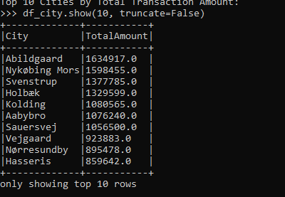

Query 2 – Average Withdrawal Amount by Card Type
SELECT CardType, AVG(Amount) AS AvgAmount
FROM fact_transactions
GROUP BY CardType
ORDER BY AvgAmount DESC;

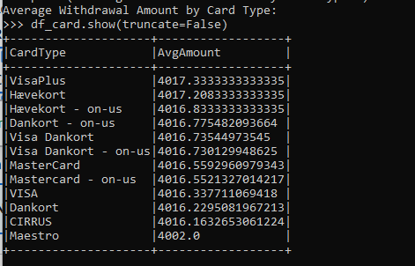

Query 3 – ATM Status Distribution
SELECT ATM_Status, COUNT(*) AS Count
FROM dim_atm
GROUP BY ATM_Status;
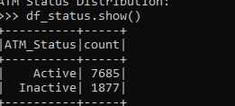

Query 4 – Monthly Transaction Trend
SELECT Month, SUM(Amount) AS TotalAmount
FROM fact_transactions
GROUP BY Month
ORDER BY Month;
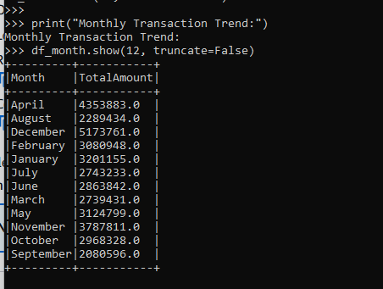

Query 5 – Weather Condition vs Total Transactions
SELECT Condition, SUM(Amount) AS TotalAmount
FROM fact_transactions
GROUP BY Condition
ORDER BY TotalAmount DESC;
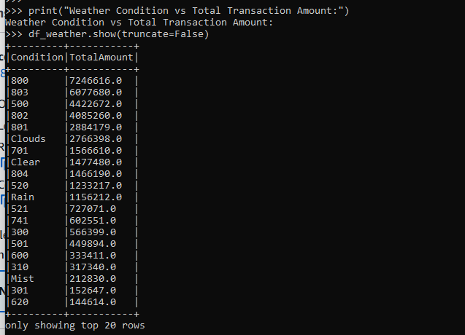
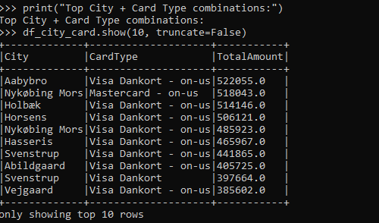

3. Key Insights
Aspect | Observation
Top City | Abildgaard (≈ 1.63 M DKK)
Highest Card Usage | Visa Dankort
Average Withdrawal | ≈ 4,016 DKK
ATM Status | Mostly Active
Weather Impact | Transactions frequent in Rain/Mist

4. Validation Summary
Stage | Record Count
Raw Data (Sqoop Import) | 2,468,572
Cleaned Valid Records (PySpark) | 9,562
Location Dimension | 106
Card Type Dimension | 12
ATM Dimension | 113
Date Dimension | 365
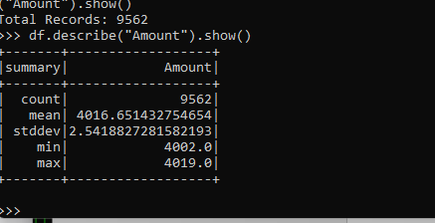

5. Conclusion
- Cleaned and validated ATM dataset successfully loaded from S3.
- Analytical queries executed to generate insights on city, card type, and weather patterns.
- Results verified and consistent with dimension and fact tables.

